**Project Report**

On

Vidyadayinee Online Study Web Portal

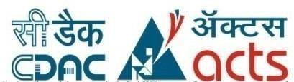

*Submitted*

*In partial fulfilment*

*For the award of the Degree of*

PG-Diploma in Advance Computing

## (C-DAC, ACTS (Patna))

**Guided By: Submitted By:**

Mr. Abushama Ansari

Choudhary Dinesh Jeevan (220980720031)

Pankaj Mude (220980720071)

Kapil Patil (220980720072)

Adarsh Ravindran (220980720005)

Shridhar Jakkan (220980720104)

**Centre for Development of Advanced Computing (C-DAC), ACTS (Patna-800001)**

## Acknowledgement

Apart from the efforts of team, the success of any project depends largely on the encouragement and guidelines of many others. We take this opportunity to express our gratitude to the people who have been instrumental in the successful completion of this project. The completion of any inter-disciplinary project depends upon cooperation, co-ordination and combined efforts of several sources of knowledge.

We are grateful to our Mentor **Mr. Abushama Ansari** for his valuable advice and direction under which we executed this project.

We take this opportunity to thank the Head of the department **Mr. Saket Jha** for providing us with such a great infrastructure and environment for our overall development.

We express sincere thanks to **Shri Aditya Kumar Sinha**, Director of C-DAC Patna, for their kind cooperation and support towards the completion of our project.

It is our great pleasure in expressing sincere and deep gratitude toward **Mr. Aditya Saha** (Course Coordinator, PG-DAC) for their valuable guidance and constant support throughout this work and helps to pursue additional studies.

Also our warm thanks to **C-DAC ACTS, Patna** which provides us with this opportunity to carry out this prestigious Project and to enhance our learning in various technical fields.

Choudhary Dinesh Jeevan (220980720031)

Pankaj Mude (220980720071)

Kapil Patil (220980720072)

Adarsh Ravindran (220980720005)

Shridhar Jakkan (220980720104)

## ABSTRACT

In today's fast-paced world, where technology has become an integral part of our lives, online learning has emerged as a popular mode of education. With the advancement of the internet and the availability of numerous digital resources, online learning has made education more accessible and convenient. The COVID-19 pandemic has further accelerated the adoption of online learning, with schools, colleges, and universities switching to online platforms to deliver education.

The Online Study Web Portal is a platform designed to cater to the needs of students and instructors in the online learning ecosystem. The platform provides a comprehensive and user-friendly interface that facilitates easy communication and interaction between students and instructors. With three main modules - Admin, Instructor, and Student - the platform offers a holistic approach to online learning.

# Table of Contents

|  |  |  |
| --- | --- | --- |
| **S. No** | **Title** | **Page No.** |
|  | **Front Page Acknowledgement Abstract**  **Table of Contents**  **Table of Figures** | **I II III**  **IV**  **V** |
| **1** | **Introduction** | **01** |
| **2**  **2.1** | **Methodology/ Techniques**  Introduction | **02-05**  **02** |
| **2.2** | Functional Requirement | **02** |
| **2.3** | Non-Functional Requirement | **04** |
| **2.4**  **2.5** | Safety Quality Attributes  Methodology and Technologies | **04**  **05** |
| **3**  **3.1** | **Implementation**  Implementation | **06-10**  **06** |
| **3.2**  **3.3** | E-R Diagram  Use Case Diagram | **07**  **08-10** |
| **4** | **Results** | **11-13** |
| **4.1** | Results | **11** |
| **5** | **Conclusion** | **14** |
| **5.1** | Conclusion | **14** |
| **6** | **References** | **15** |
| **6.1** | References | **15** |

# Table of Figures

|  |  |  |
| --- | --- | --- |
| **Fig. No.** | **Title** | **Page No.** |
| 1 | E-R Diagram | 07 |
| 2 | Instructor Use Case Diagram | 08 |
| 3 | Student Use Case Diagram | 09 |
| 4 | Admin Use Case Diagram | 10 |

**Chapter 1**

## Introduction

In an era known as the society of technology and knowledge, where lifelong learning is a way of life, it is important that educational institutions have effective ways of providing new learning opportunities to make learning more efficient, equitable and innovative. Before the advent of online study tools, learners and educators faced several challenges such as geographical barriers, time constraints, limited interactivity and high cost of offline study.

Vidyadayinee Online Study Web Portal is a project aimed at providing an efficient and user-friendly platform for students and instructors to connect and engage in online learning. The portal is divided into three main modules - Admin, Instructor, and Student.

The Admin module is responsible for managing the entire platform, including student and instructor profiles, and courses created by the instructors. Instructors are required to register on the platform and send a request to the admin for approval. Upon approval, the instructor can create courses, which are then made available to students.

The Instructor module allows approved instructors to create courses and manage their content. Instructors can upload video lectures and other study materials.

The Student module is designed for students to register for courses created by instructors and purchase them using an payment gateway. After purchasing a course, students gain access to all the course materials, including video lectures and study material.

The purpose of the project is to provide a better education experience and build an application program to reduce the manual work and make it easier for students to access high-quality education and for instructors to create and manage their courses.

# Chapter 2 Methodology and Techniques

## Introduction:

The Online Study Web Portal project is developed using Spring Boot and ReactJs frameworks. Spring Boot is a popular Java-based framework used for building web applications. ReactJs is a JavaScript library used for building user interfaces. The project uses various other technologies and tools such as Bootstrap, CSS, HTML, and MySQL database.

## Functional Requirements

Operating Environment:

2.2.1 Hardware Platform:

• Processor: Above Pentium 4, with clock speed of 2.0 GHz

• RAM: 2GB or Above

• Hard Disk: Free disc space above 1GB

2.2.2 Software Platform:

• Front End: HTML, CSS, Bootstrap, ReactJS.

• Back End: MySQL, Spring Boot Framework.

2.2.3 Supported Tools:

• MySQL Workbench, Eclipse, STS.

• Web Server: Tomcat 9.0.

**J2EE:** Java 2 Enterprise Edition (J2EE) is a platform for developing enterprise-level web applications using Java. It provides a set of APIs for building scalable, distributed, and secure web applications.

**SpringBoot:** Spring Boot is a Java-based framework that provides a pre-configured environment for developing and deploying web applications. It allows developers to focus on writing business logic instead of configuring the environment.

**MySQL:** MySQL is an open-source relational database management system. It is widely used in web applications as a backend database. It provides various features like ACID compliance, transactions, and scalability.

**ReactJS:** ReactJS is a JavaScript library for building user interfaces. It provides a declarative programming model, which allows developers to create reusable components and manage state efficiently. It is widely used in building single-page applications.

**BootStrap:** Bootstrap is a popular front-end framework for building responsive web applications. It provides a set of pre-built UI components, such as navigation bars, forms, and buttons, that can be easily customized to match the design of the application.

**TomcatServer:** Apache Tomcat is an open-source web server and servlet container. It provides a platform for deploying and running Java web applications. It is widely used in production environments as it is easy to configure and provides good performance.

**IntelliJ Idea:** IntelliJ IDEA is an integrated development environment (IDE) for Java developers. It provides various features like code completion, debugging, and testing, that help developers to write code efficiently.

**VS code:** Visual Studio Code is a lightweight, open-source code editor. It provides a wide range of features like code completion, debugging, and version control integration. It is widely used by developers for building web applications, mobile applications, and cloud-based applications.

## Non-Functional Requirement

2.3.1 Performance Requirements: -

The system should store all the database records of each instructor and student properly and the application should be available for use 24*7 through the server. Also, the application should be user friendly with a proper user interface which makes it easy for the user to understand. All the options should be present in properly accessible for user convenience.

2.3.2 Safety Requirements: -

All login ids and passwords of the admins, instructor and students should be protected for privacy using whatever constraints required in the database or the application. Admins, instructor, properties and student’ records are to be backed up securely across database servers. Incase database is hacked by someone, and data is deleted a backup server should be present for such purpose.

* 1. **Software Quality Attributes**

2.4.1 Availability

The system should run on a variety of operating systems that support the JavaScript language. The system should run on a variety of hardware

3.2 Accessibility

The software will be accessible to admins, builders and users.

3.3 Compatibility

The software will be compatible with multiple platforms.

3.4 Durability:

The software will be tested for working with multiple users.

3.5 Effectiveness

The software will be made to handle operations effectively.

* 1. **Methodology and Technologies:**

Waterfall Methodology: The Waterfall methodology is a linear approach to software development that can be used to develop the Online Study Web Portal project. The methodology involves a sequential process of requirements gathering, design, implementation, testing, and maintenance. We first defined and documented the requirements for the admin, instructor, and student modules of the Online Study Web Portal later we designed the system architecture, database schema, and user interface, and used Spring Boot and ReactJs frameworks to develop the system.

RESTful Web Services: The project uses RESTful web services to interact with the backend. RESTful web services are a popular architectural style used for building web services. RESTful web services use HTTP methods to perform operations on resources. The project uses the Spring Web framework to develop RESTful web services.

Spring Data JPA: The project uses Spring Data JPA to interact with the database. Spring Data JPA is a popular data access framework that simplifies the development of data access layer in Spring applications. Spring Data JPA provides a set of repositories that simplify the CRUD (Create, Read, Update, and Delete) operations on entities.

ReactJs: The project uses ReactJs to develop the frontend. ReactJs is a popular JavaScript library used for building user interfaces. ReactJs uses a virtual DOM (Document Object Model) to update the user interface efficiently. ReactJs enables the project team to develop reusable components and manage state effectively.

Bootstrap: The project uses Bootstrap to develop responsive and mobile-first user interfaces. Bootstrap is a popular front-end framework that provides a set of CSS and JavaScript components. Bootstrap enables the project team to develop consistent and responsive user interfaces.

MySQL Database: The project uses MySQL database to store the data. MySQL is a popular relational database management system (RDBMS) used for storing and retrieving data. MySQL provides a set of tools for managing databases and tables.

# Chapter 3

**IMPLEMENTATION**

**3.1 Implementation**

* + 1. Choosing a Programming Language and Framework: We chose Java programming language and SpringBoot framework for our project. As SpringBoot simplifies the process of building web application in java by providing several tool and features. It includes a set of preconfigured components and setting that make it easy to create applications quickly.
    2. Designing the Database Schema: The next step is to design the database schema for the system. We defined the tables, columns, and relationships between them.
    3. Implementing the Admin Module: The Admin module is responsible for managing student and instructor accounts, courses, and content on the platform. You will need to create an admin interface where an admin user can log in and manage the system's different components.
    4. Implementing the Instructor Module: The Instructor module enables instructors to create and manage courses on the platform. Once an instructor registers, they will send a request to the admin to approve their account. Once approved, instructors can create and manage courses.
    5. Implementing the Student Module: The Student module enables students to browse and enroll in courses on the platform. Students can register on the platform, search for courses, and enroll in courses they are interested in. After enrolling, they can access course materials such as videos, lectures, and assignments

# 3.2 E-R Diagram

# 

# 3.3 Use Case Diagram

# 3.3.1 Instructor Use Case Diagram

# 

# 3.3.2 Student Use Case Diagram

# 

# 3.3.3 Admin Use Case Diagram

# 

# Chapter 4

**RESULTS**

The Above Online Study Web Portal project has successfully achieved its objectives of developing an online study platform that is accessible and user-friendly. Here instructor can register into the web portal. After registration instructor is able to login and send approval request to admin. Once approved by admin, instructor is able to create courses, add chapter, add topic, add sub-topic and upload videos. In student module, student is able to register and login. After login student successfully enroll into the courses created by instructor. Admin is able to manage instructor, student and courses.



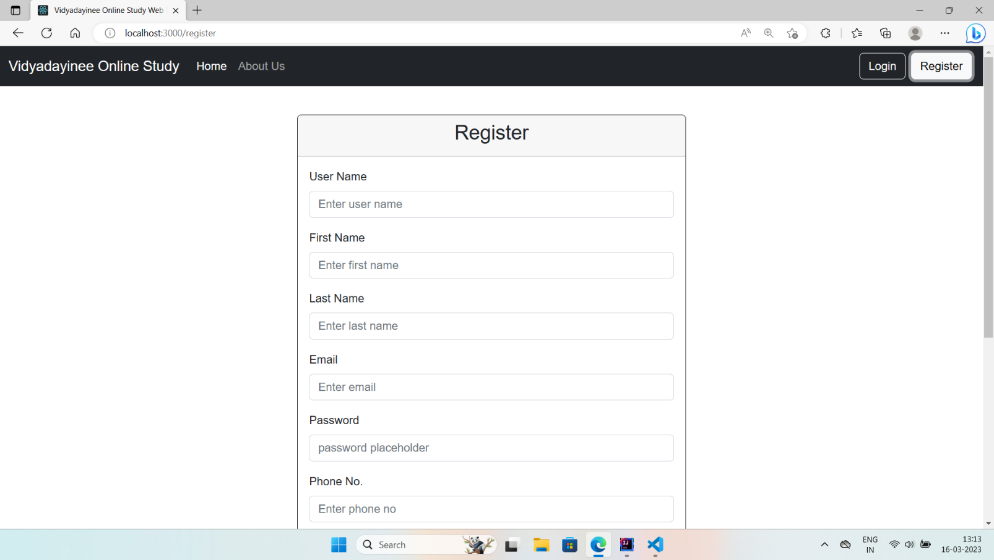

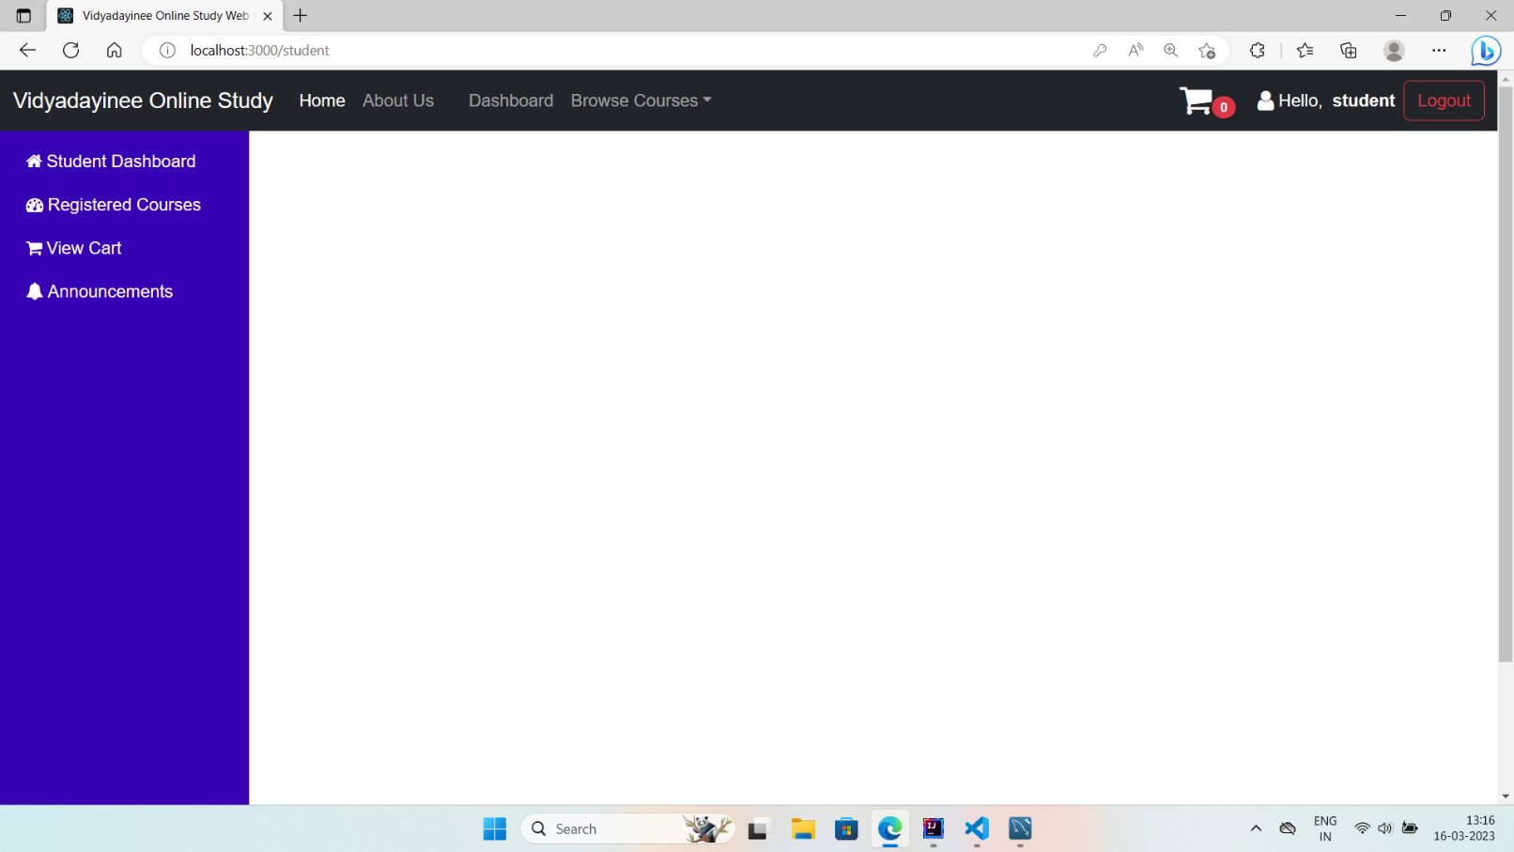

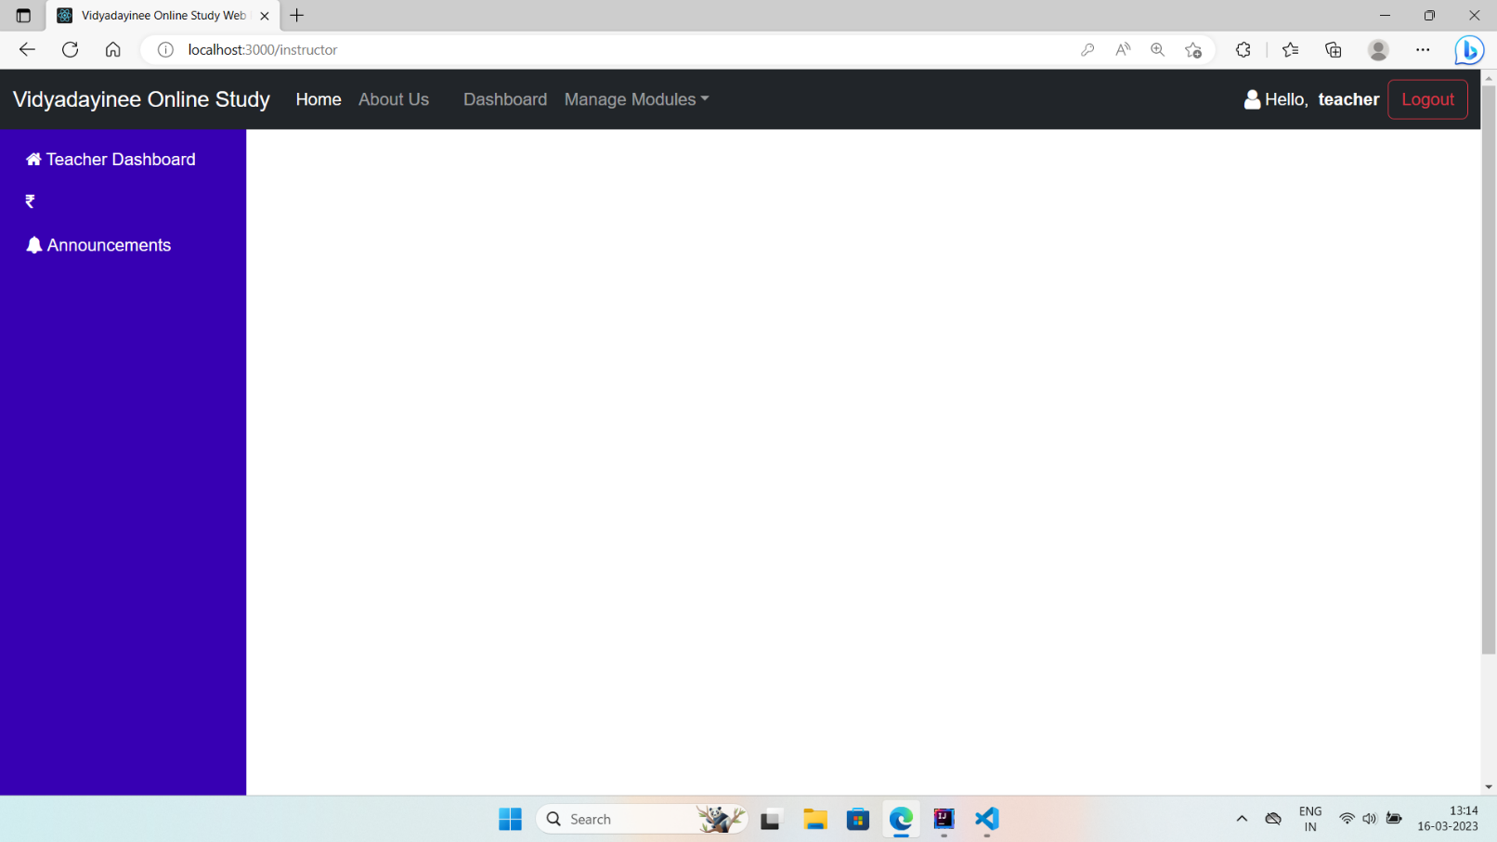

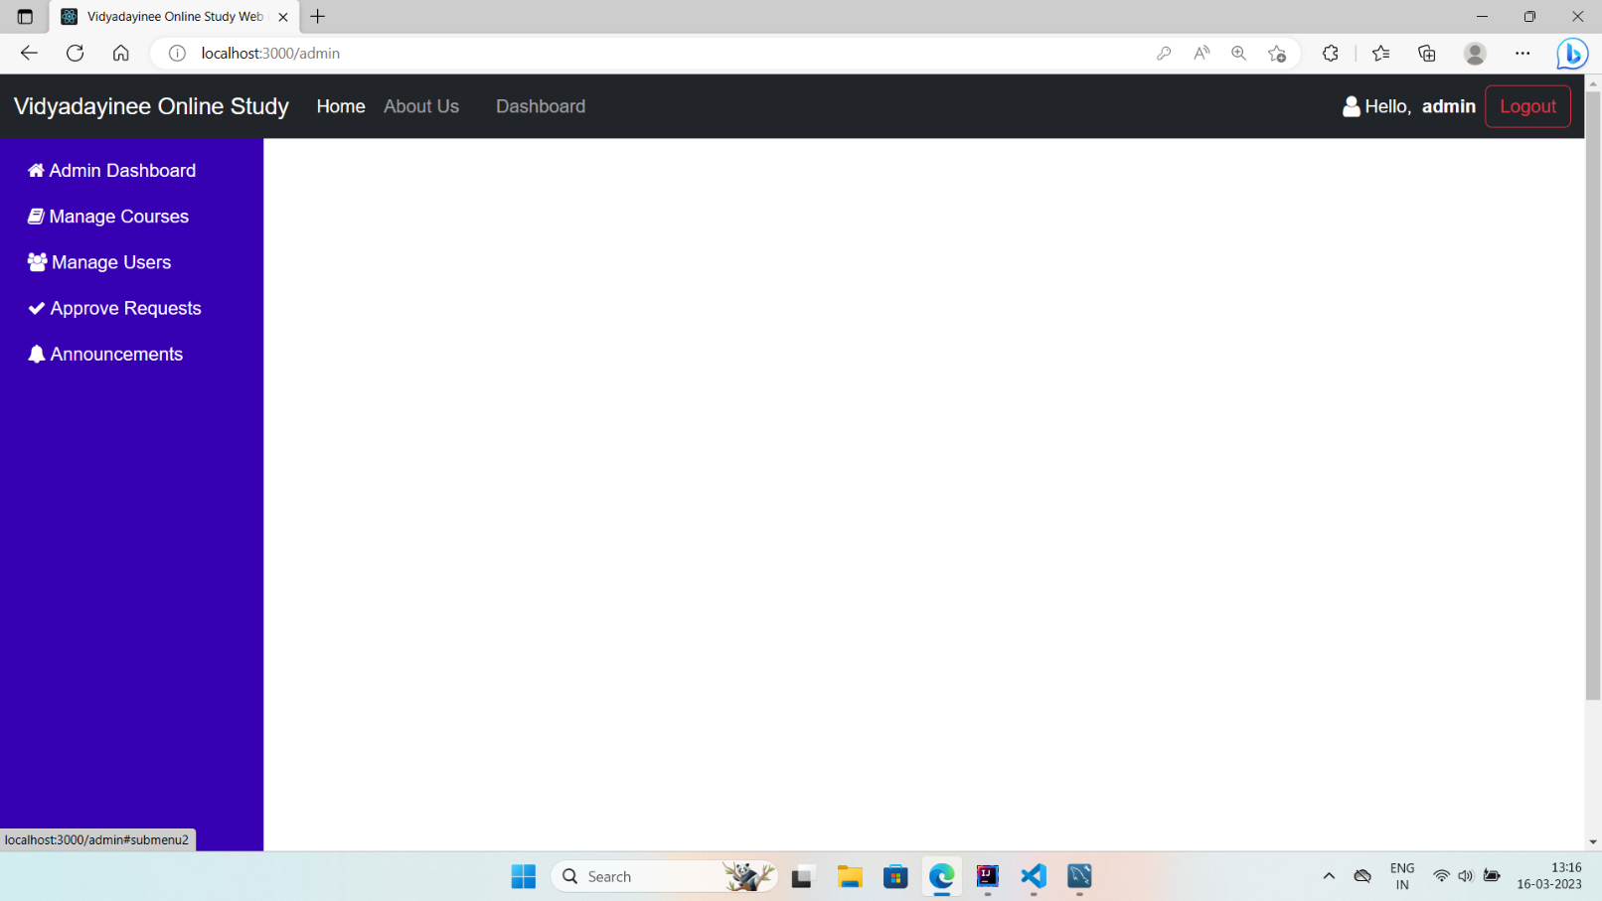

# Chapter 5 CONCLUSION

The Online Study Web Portal is a comprehensive and user-friendly platform that caters to the needs of modern-day learners and instructors. With its intuitive user interface and personalized learning paths, the platform offers a seamless and engaging online learning experience for students. The platform also provides instructors with the tools they need to create and manage courses on the platform, enabling them to reach a wider audience and enhance their teaching methods.

The project's main objective was to create an innovative online learning platform that offers an immersive learning experience for students and instructors. By using a three-tier architecture and the latest technologies, we were able to develop a platform that is easy to use, engaging, and effective. The platform's modular design allows for easy integration of new features and functionalities, ensuring that it can adapt to the changing needs of learners and instructors.

# Chapter 6

**REFERENCE**

* **https://www.researchgate.net/publication/267391712_Step_by_step_building_an_e-learning_project**[**https://projectsgeek.com/2014/04/e-learning-management-system.html**](https://projectsgeek.com/2014/04/e-learning-management-system.html)
* [**https://www.slideshare.net/YashrajNigam/e-learning-project-report-yashraj-nigam**](https://www.slideshare.net/YashrajNigam/e-learning-project-report-yashraj-nigam)
* [**https://www.researchgate.net/publication/267391712_Step_by_step_building_an_e-learning_project**](https://www.researchgate.net/publication/267391712_Step_by_step_building_an_e-learning_project)
* [**https://nevonprojects.com/e-learning-system/**](https://nevonprojects.com/e-learning-system/)
* [**https://tororaligu.files.wordpress.com/2015/06/project-report-for-e-learning-pdf.pdf**](https://tororaligu.files.wordpress.com/2015/06/project-report-for-e-learning-pdf.pdf)
* [**https://www.researchgate.net/publication/335463920_Learning_Management_Systems_An_Overview**](https://www.researchgate.net/publication/335463920_Learning_Management_Systems_An_Overview)
* [**https://www.slideshare.net/tomilayolawani/elearning-system**](https://www.slideshare.net/tomilayolawani/elearning-system)
* [**https://t4tutorials.com/e-learning-management-system-project-in-php-mysql-projects-for-mcs-mit/**](https://t4tutorials.com/e-learning-management-system-project-in-php-mysql-projects-for-mcs-mit/)